Approvals:
Name | Job Title | Signature | Date
Scott Pletzer | Director of Quality & Program Management
Andrew Mason | Chief Technology Officer

Revision History
Revision | Revision Date | Reason for Revision/Change Request | Revised By
000 | 28Jun12 | Initial Release | S. Pletzer

- Purpose
The purpose of this document is to describe the specifications for the ClearView synchronization service which bridges interaction between ClearView and EPIC Central.
- General Requirements
Where appropriate, logic should be contained in try/except blocks and any exceptions should be logged using the standard logging mechanisms.
- Specifications
Items listed below align directly with section 4.x in the Synchronization Service Requirements.
  - The service is installed as a Windows server. It can be started as a standalone application or started from the Services utility in Windows Administration.
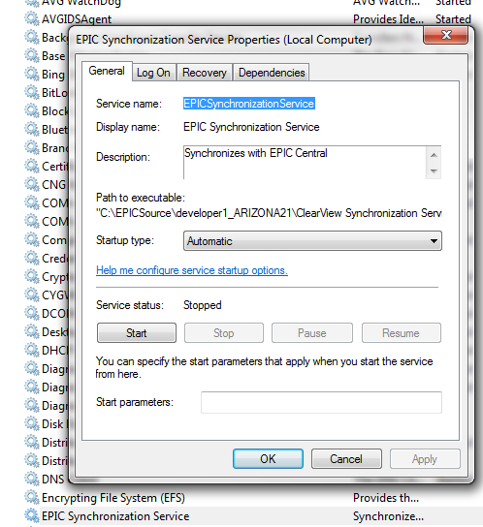
  - A rolling log is created using the log4net API.
http://logging.apache.org/log4net/
  - The service starts automatically when the computer boots via the Windows service manager displayed above.
  - The debug console can be started by launching the same application displayed in the Path to execute in the dialog above.
    - The console requires administrative privileges. If a user does not have administrative privileges they will be prompted to enter them by Windows.
    - All interactions are logged to Console display:
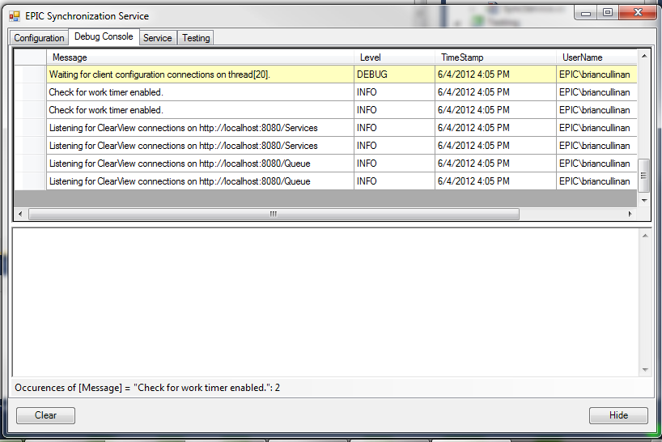
    - All service transactions are shown in the view above whether the entry was created by the dialog or by the Windows service.
    - Historical counts can be viewed on the Services tab:
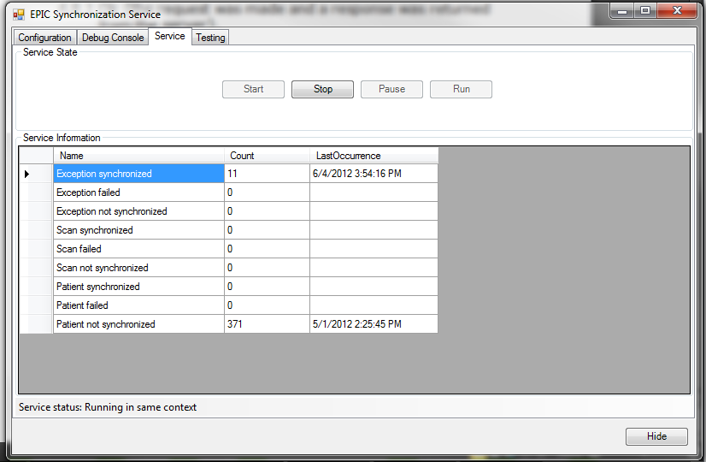
  - The service dialog can be closed and opened independently of the Windows service by launching the same applications the Windows service runs.
  - The counts are shown on the Services tab, this view is updated in real time every time a Services or a Queue call is made, or when the Transaction Manager is executed.
  - Depending on the function, some items are queued for synchronization and some actions return a value immediately.
  - The three conditions returned by the service are defined below:
    - If the function call is a Queuing event, it will always queue and succeed if the Local service can be reached.
    - If the local service cannot be reached an EndpointNotFoundException is thrown.
    - If the EPIC Central service cannot be reached on a service call that requires immediate feedback, the exception will be thrown to ClearView. And Internal Error will be thrown for all errors not related to EPIC Central and will be logged.
  - The items in the queue will be retried the number of time defined by the Retries setting on the Configuration tab.
  - All queued items are stored in a database.
  - The Language can be selected on the Configuration tab; this controls the language for all events that occur within the synchronization service, as well as the appearance of the management dialog.
Languages are loaded dynamically from the Languages directory.
  - All communication between ClearView and the synchronization service is done over HTTP, this is the default binding for WFC services.
  - When the configuration is changed in the service management console the Windows service is updated automatically and the new settings are applied.
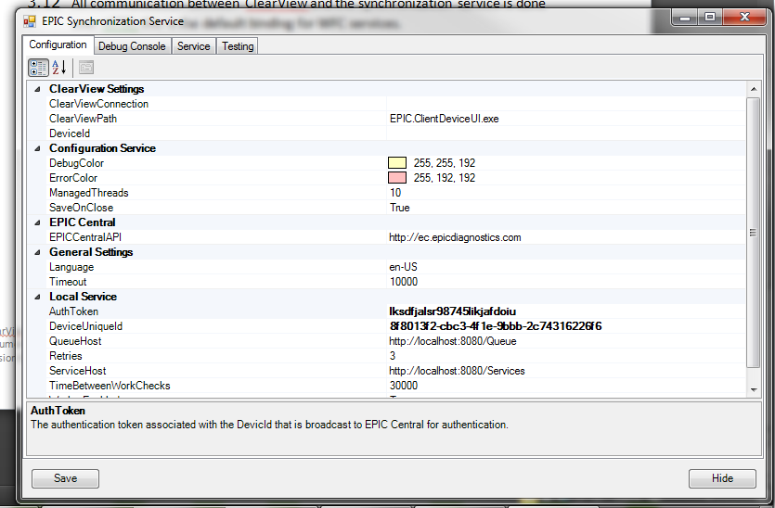
  - EPIC Central is pinged at the increment defined on the Configuration tab regardless of work to do.
  - The service stored the authentication information in an encrypted app.config file. If there is no authentication information, the Ping function will throw WebFaultExceptions with the specified status codes.
  - All service calls from EPIC Central are exposed to ClearView. This can be verified by comparing the Web Service Reference Wizard to the EPIC Central Web Services Specification.

